June 10 Intake P1  - 243+810x+1080x²  - y = -2 @ y = 4  - i. m=7/2  ii. 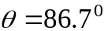  - i. -3,-1,1  ii. d=2  iii. n(n-4)  - i.  ii. 23.6⁰, 156.4⁰, 270⁰  - i. r = 0.9  ii. a = 8  iii. 79.588  iv. 0.412  - i. (x-3)²+9  ii. minimum graph with y-  intercept is 18 and  minimum point of (3,9)  iii. 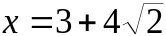  - i. y = 5, 26  ii. 343/6 unit²  - i. BD=5.6cm  ii. perimeter=15.7cm  iii. R=5.95cm²  - i.  ii. 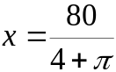  iii.  iv.448m² | June 10 Intake P6  - i. 90720  ii. 20160, 2/9  - i. 0.244  ii. 0.102  - i. 0.9332  ii. 0.4852  - i. P(X=3)=11/13, P(X=1)= P(X=2)=1/13  ii. E(X)=36/13, Var(X)=56/169  - i.  ii. Generally marks for country E evenly  distributed and marks for country C  positively skewed  iii. Illustrate the spread of the data.  Frequency of data are not shown.  - i .30 000  ii. 34 – 31, median = 24.5  iii. mean = 27.5, Std deviation = 11.2  - i. 2/5  ii. 0.224  iii. 0.944  iv. 0.35  v. A and B are independent  vi. B and C are mutually exclusive
Jan/Mac 10 Intake P1  - 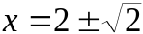  - i. 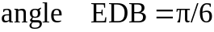  ii. Area = 1.08cm²  - i. 1-24x+264x²+…  ii. 192  - i.  ii. 23.6⁰, 156.4⁰, 270⁰  - i. 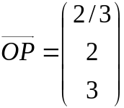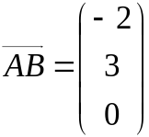  ii. 69.3⁰  - i. 36 unit²  ii. 40.5π unit²  - i. 2(x+3)²-5  ii.k = -3  iii. 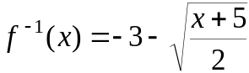  iv.  - i. 167 000  ii. 124 000  - i.  ii. A is minimum  iii. A= 300m²  - i. k = 6  ii. 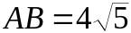  iii. Area = 10 unit²  iv. y + 2x = 6 | Jan/Mac 10 Intake P6  - m=8, n=3  m=7, n=4  m=6, n=5  - 20  - i. Boxes are independent  ii. 0.187  iii.0.160  - i. h= 2  ii. 60  iii. 7.60  - i.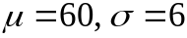  ii. n=150  - i. P(A) = 0.5, P(A\C) = 0.5  A and C are independent  ii. P(B) = 7/72, P(A\C) = 1/6  B and C are not independent  - i. a=4/5, b=1/5  c=1/4, d=3/4  e=3/4, f=1/4  ii. 9/20  iii. k=1/4  iv. E(X)= 1.75, Var(X)= 63/80
Jun 09 Intake P1  - 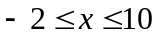  - 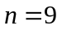  -34642080  - –  - 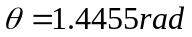  - s=6  101.0°  - 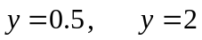  - 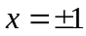  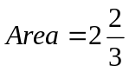  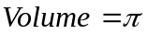  - 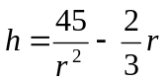  r =3  Minimum  - 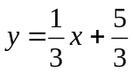  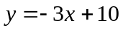  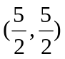  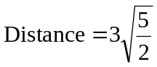  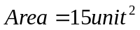  - 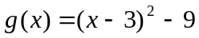  k=3  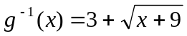  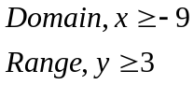  - 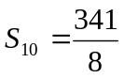  a=64  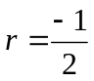  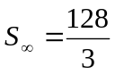  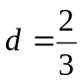  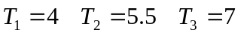 |  | Jun 09 Intake P6  - 141120  - 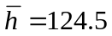  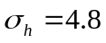  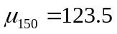  - 0.495  - 0.604  - a)  - 0.250  - 0.758  b) 0.0433  - 7-9,  IQR=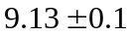  - 32  - 10  - 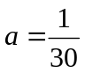  - 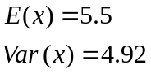  -   - 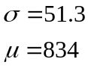  b) 0.8185  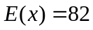

Jan 09 Intake P1  - 90720  - 2460  - 0.927 rad; 35.1  - (i) 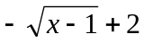; (ii) 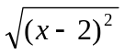; (iii) 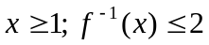; (iv) reflection on the line y=x  - (i) show; (ii) 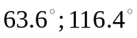  - (i) (10, 0); (ii) 1:3  - (i) a = 1, b = 2; (ii) sketch;  (iii) 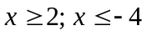  - (i) 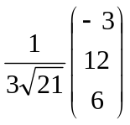; (ii) p = 2; (iii) (a) 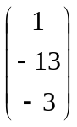; (b) show  - (a) 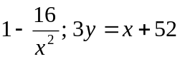;  (b) (ii) 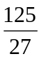  10. (a) (i) 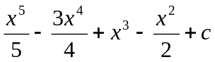  (ii) 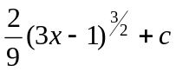  (b) | Jan 09 Intake P6  - (i) 8; (ii) 9.17  - (i) (a) 2; (b) 3; (c) 2, 4; (ii) draw  - (i) draw; (ii) 0.115; (iii) 0.391  - 362880; (i) 100800; (ii)302400  - (i) 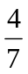 ; (ii) 0.360; (iii) 0.734  - (i) 14.25; (ii) 736; (iii) 462  - (i) 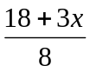; (ii) x = 4; (iii) loss = $18.75 or gain = -$18.75.

